**Project Phase 1 Report**

**Web development Fundamentals**

**Section: L02**

**Project Name: ReadRadar**

**Group Members:**

**Ibrahim Al-Ajimi | 202003888**

**Khalifa Yousuf | 202002710**

**Omar Qutb | 202106170**

**GitHub Repository:**

[**https://github.com/e-7-7-7/Web-Project**](https://github.com/e-7-7-7/Web-Project)

**Web Development Project Report**

**Project Description:**

Our ReadRadar project aims to modernize online book sales by offering a user-friendly platform designed for three main types of users:

1. **Admin**: Admins keep things running smoothly on ReadRadar. They make sure all book listings meet quality standards and remove anything inappropriate. Admins also approve books added by sellers.
2. **Seller**: Sellers are key to our platform's growth. They can add new books for sale and manage their listings. Sellers wait for admin approval before their books go live. They can also tweak book details and track their sales.
3. **Customer**: Customers are the heart of ReadRadar. They can easily browse and buy books that interest them. They can also have a look on their purchase history.

We organize our books into different genres, making it simple for customers to find what they're looking for. Whether it's action-packed adventures, mysterious thrillers, self-help guides, or captivating Arabic literature, we've got something for everyone.

ReadRadar is all about making book buying enjoyable and hassle-free. We're committed to providing a seamless experience for book lovers worldwide.

**Application design documentation:**

Our website offered several key features to users, making their experience easier.

Here's a breakdown of the main functionalities:

1. **Logging In**: Users could easily access their accounts by logging in with their credentials.
2. **Adding an Item**: Adding items to the platform was straightforward, allowing users to contribute to the product catalog effortlessly.
3. **Loading Items onto the Website**: We ensured that items were promptly loaded onto the website for users to browse through and explore.
4. **Adding Items to the Car**t: Once users found items they wanted, they could conveniently add them to their shopping carts.
5. **Purchasing an Item**: Making purchases was a simple process, allowing users to complete transactions quickly and securely.
6. **Searching**: Our search functionality enabled users to find specific items or browse through categories with ease.

In terms of data management, we primarily utilized localStorage for processing user interactions and storing essential information. While user data was initially fetched from user.json during the login process, all subsequent actions related to the user, such as adjusting balances and managing transactions, were handled within localStorage. This will later during phase 2 of the project to use a database and ability to use Web APIs making the website more dynamic through different devices.

**App Testing (Screen Shots):**

Home page (Guest View):

Guest Trying to Purchase

Logging in:

Wrong password:

Seller adding an Item

Book waiting to be approved.

Book approved by admin.

Book visible to customers.

Customer adding to cart and selecting quantity:

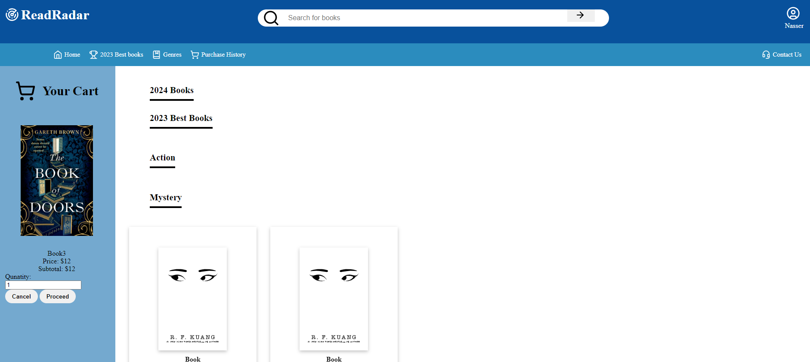

Customer proceeds to checkout

Asked if he wants to continue.

Item purchased successfully

